**Project:** Load Balancer

**Connect global load balancer to 3 different regions**

Setting up a global load balancer across three different regions is a complex and advanced networking task. It typically involves using a cloud provider's services, like Google Cloud Platform (GCP), Amazon Web Services (AWS), or Microsoft Azure. Here, I'll provide a general outline of how you can set up a global load balancer across three regions, using Azure as an example:

What is Load Balancer?

* Azure Traffic Manager. The term load balancing refers to the distribution of workloads across multiple computing resources.
* Load balancing aims to optimize resource use, maximize throughput, minimize response time, and avoid overloading any single resource.

Why use Azure Load Balancer?

* With Azure Load Balancer, you can scale your applications and create highly available services.
* Load balancer supports both inbound and outbound scenarios.
* Load balancer provides low latency and high throughput, and scales up to millions of flows for all TCP and UDP applications.

What is Global load Balancer?

* Azure Load Balancer's Global tier is a cloud-native global network load balancing solution.
* With cross-region Load Balancer, you can distribute traffic across multiple Azure regions with ultra-low latency and high performance.
* Azure cross-region Load Balancer provides customers a static globally anycast IP address.

What is the benefit for using Global Load Balancer?

* Using a global load balancer offers several benefits, especially for organizations with distributed infrastructure and global user bases. Some of the key advantages of using a global load balancer include:

**High Availability:**

* Global load balancers distribute traffic across multiple geographically dispersed data centers or regions.
* This redundancy ensures that if one data center or region experiences downtime or issues, the load balancer can automatically route traffic to healthy resources in another location, minimizing service disruptions.

**Improved Performance:**

* Global load balancers can route users' requests to the nearest or most responsive data center or server, reducing latency and improving the overall user experience.
* This is especially important for applications with geographically dispersed users.

**Scalability:**

* Global load balancers can efficiently distribute incoming traffic to a pool of backend servers or instances.
* As your application scales, you can easily add or remove resources in different regions, and the load balancer will adapt to handle the increased or decreased load.

**Geographic Traffic Management:**

* You can use global load balancers to route traffic based on geographic regions.
* This allows you to provide localized content and services to users based on their location, improving content delivery and meeting regional compliance requirements.

What is Virtual Network (Vnets) ?

* Azure Virtual Network is a service that provides the fundamental building block for your private network in Azure.
* An instance of the service (a virtual network) enables many types of Azure resources to securely communicate with each other, the internet, and on-premises networks.

What is Virtual Machines?

* A virtual machine (VM) is a digital version of a physical computer.
* Virtual machine software can run programs and operating systems, store data, connect to networks, and do other computing functions, and requires maintenance such as updates and system monitoring.

**Step by Step Process**

**Step 1:**

* Open Azure Portal and Sign in to your Account.
* Now Click on Search bar and Search Vnets
* Now Create three different Vnets with different regions.

As Shown below we have to create three different virtual networks with different regions.

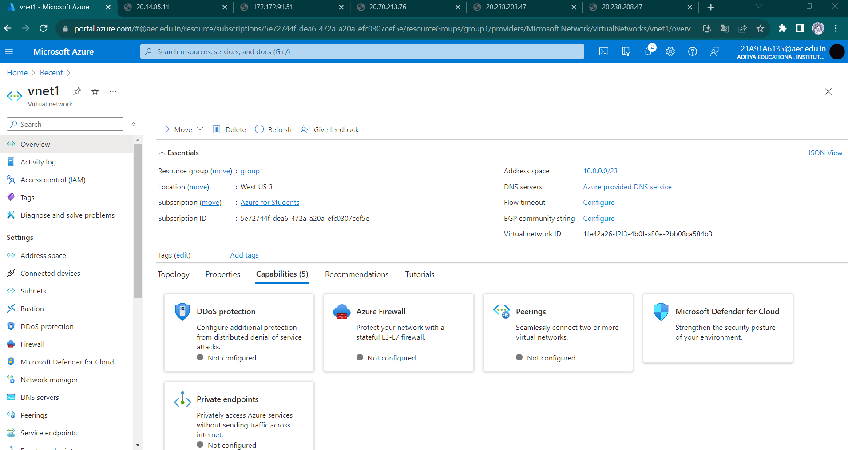

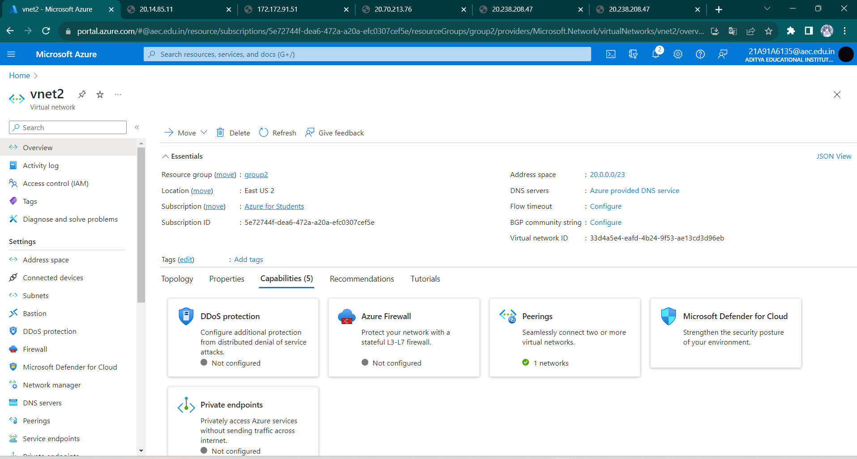

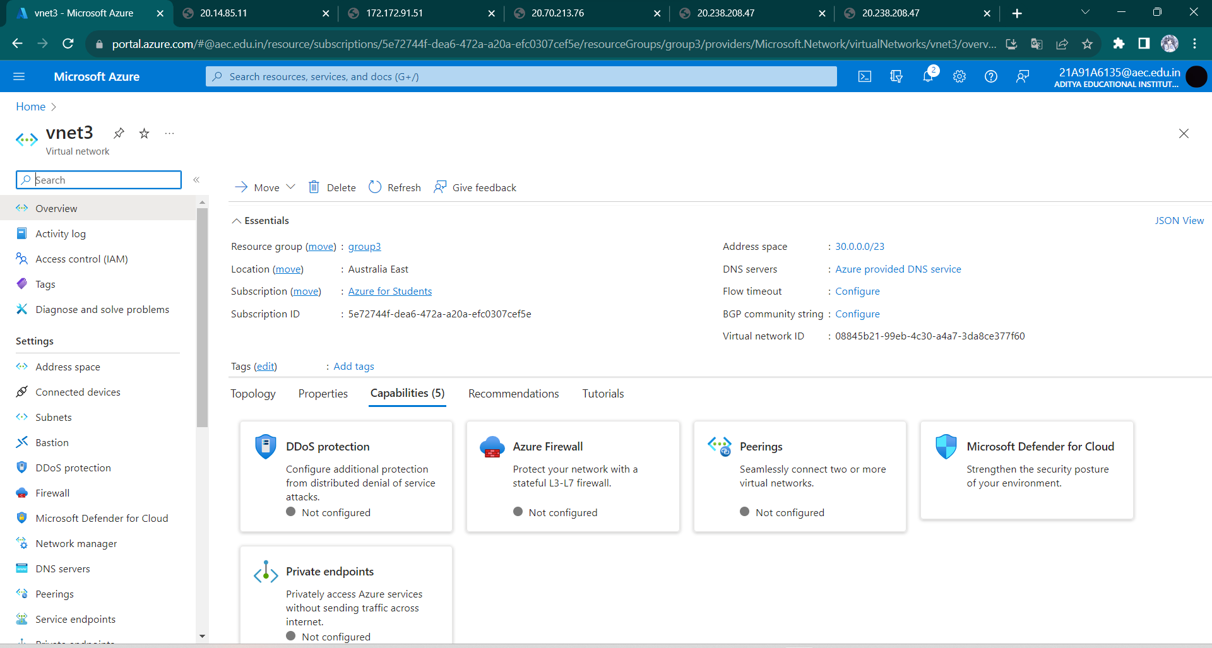

**Step 2:** In the next step for each vnet’s we have to create different virtual machines and connect it to three different load Balancers.

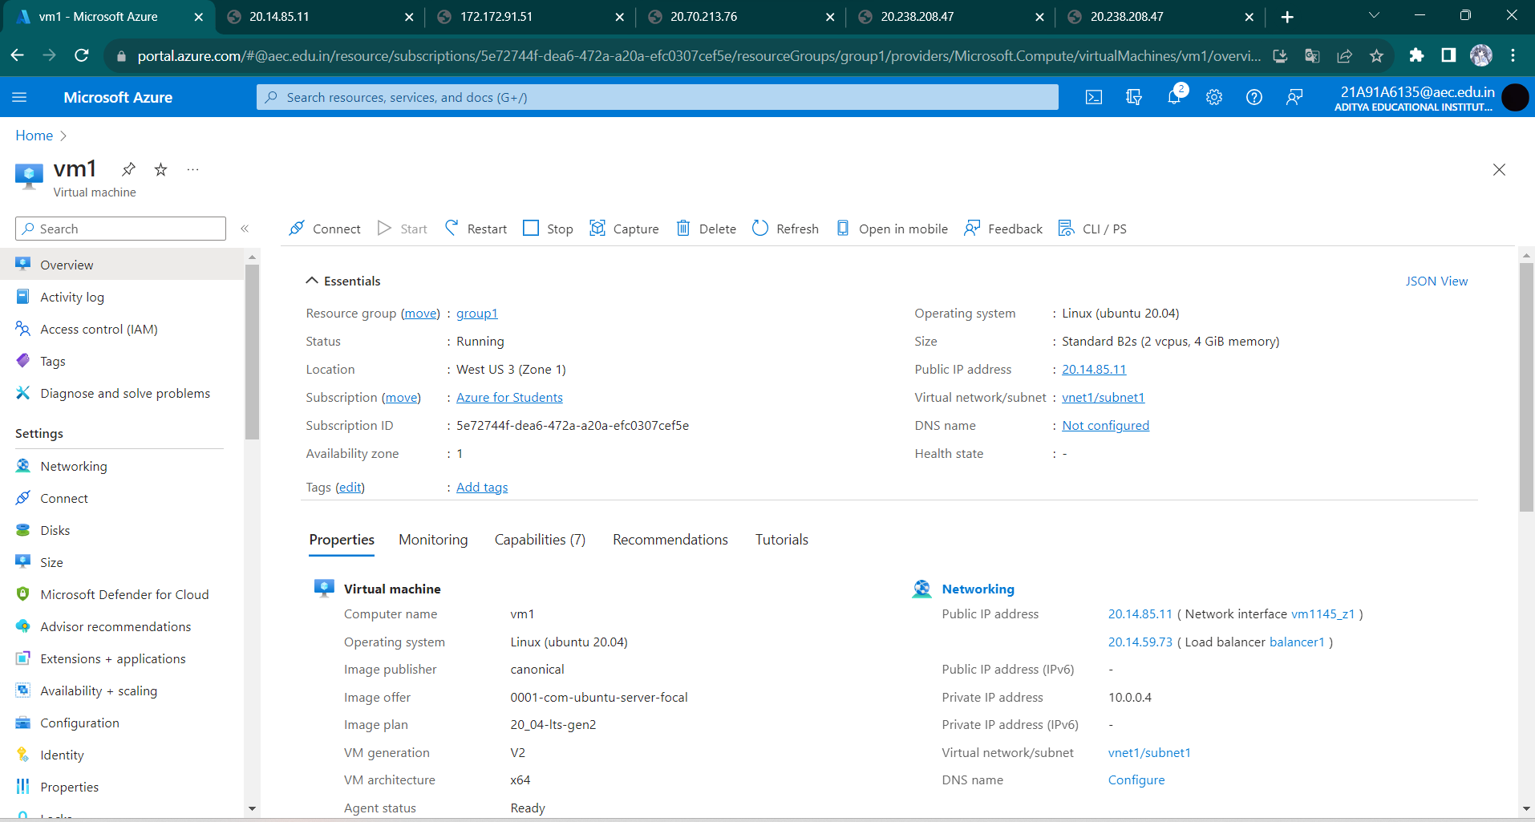

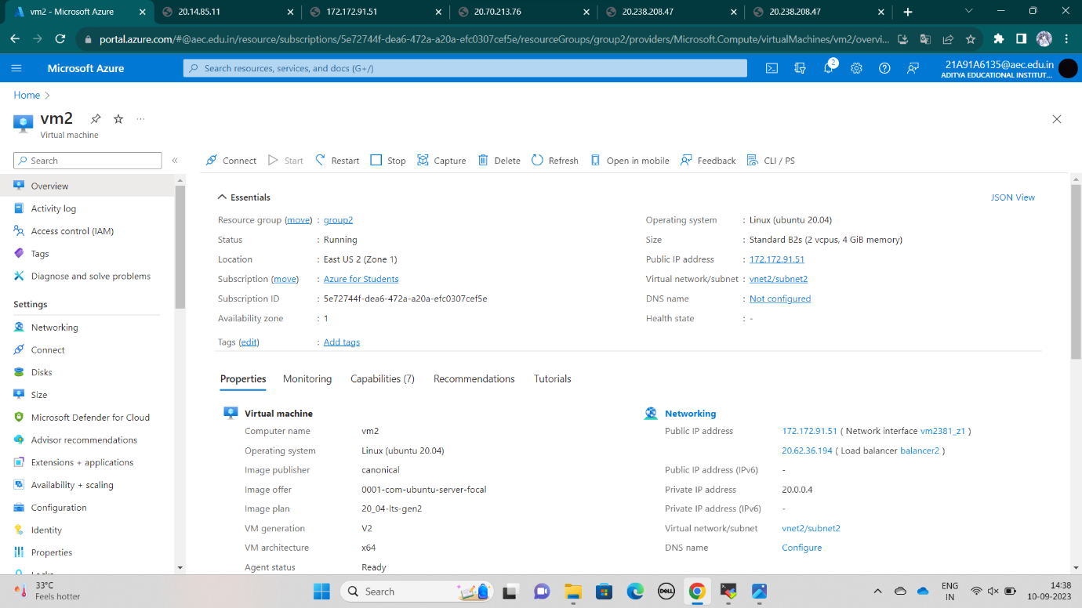

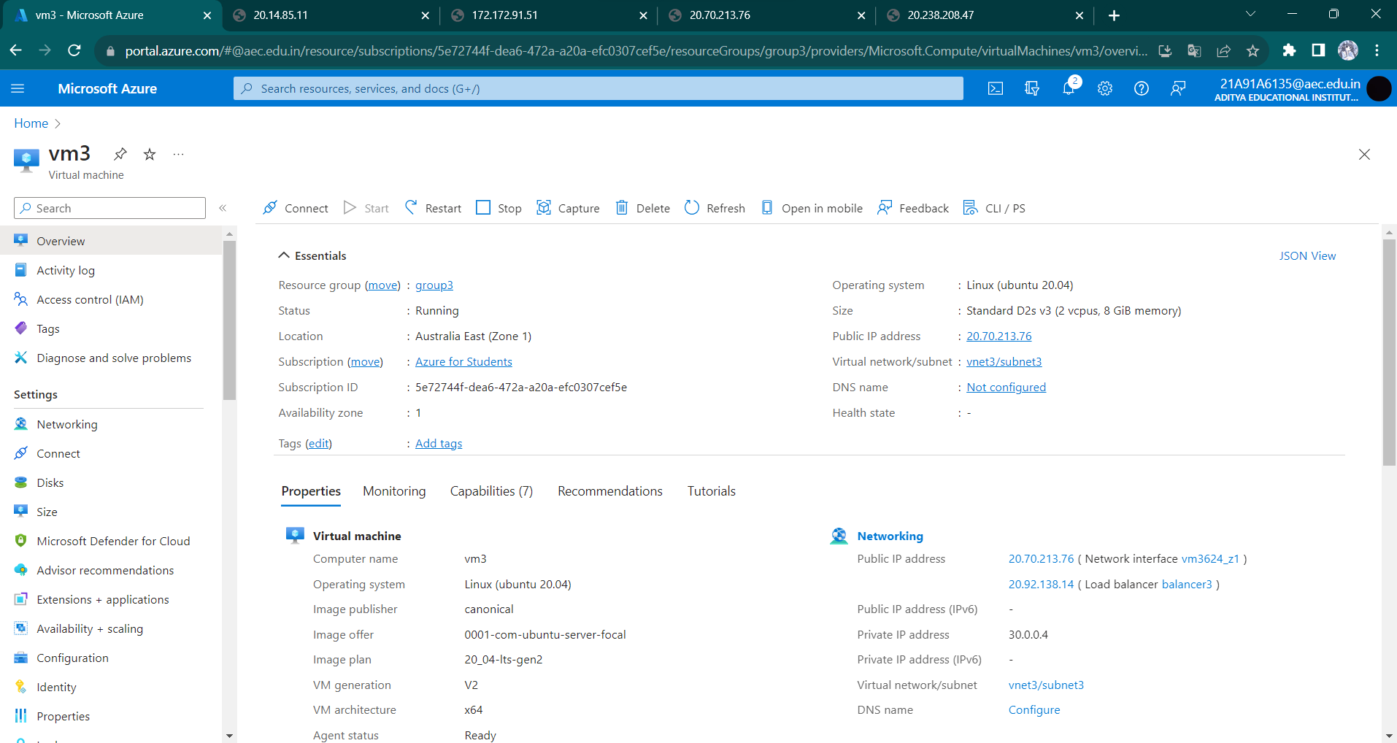

**Step 3**: Now Connect each virtual machine’s to separate load balancers.

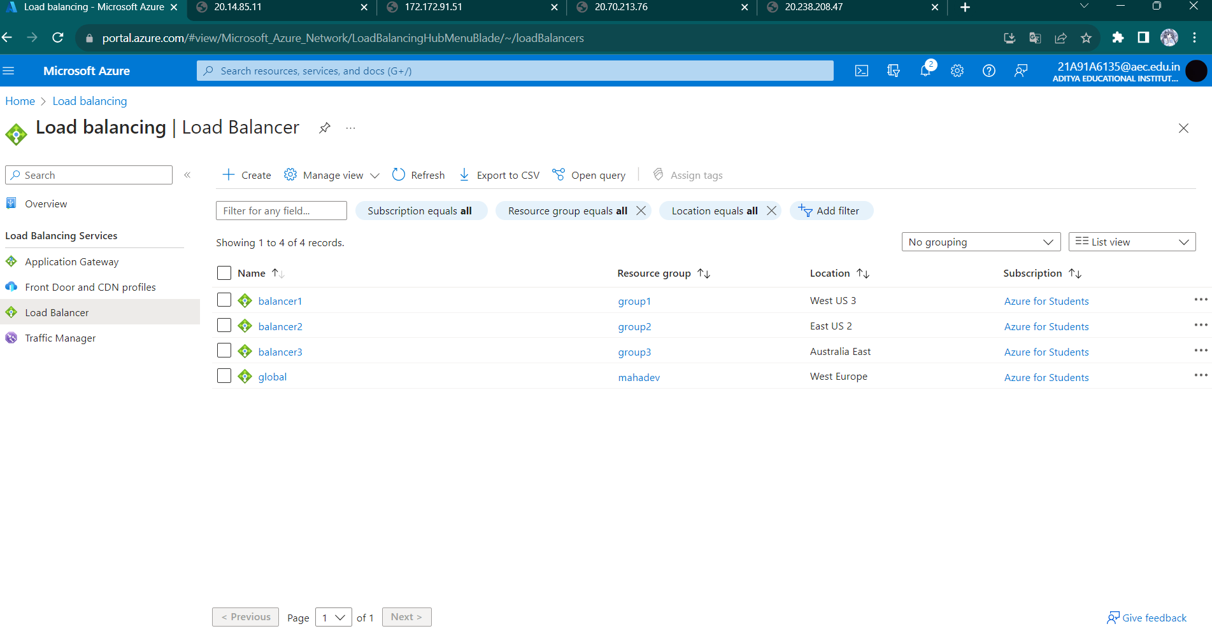

Here you can see that virtual machine one is connected to load balancer1.

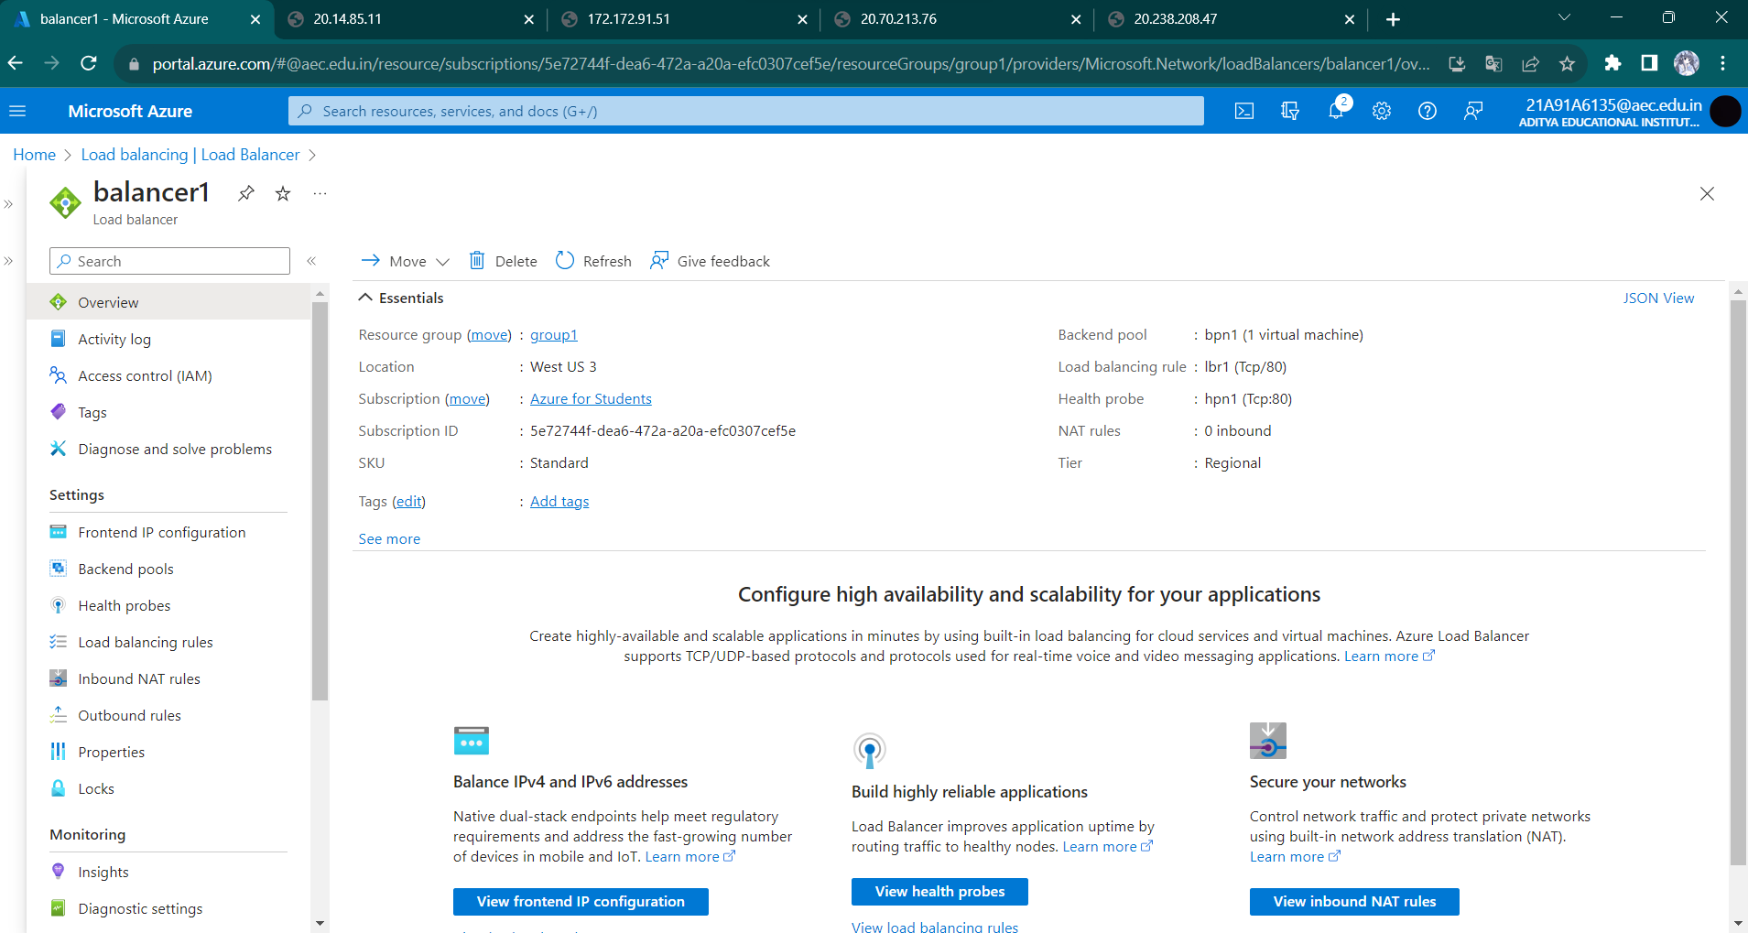

And Second Virtual Machine is connected to Second load Balancer.

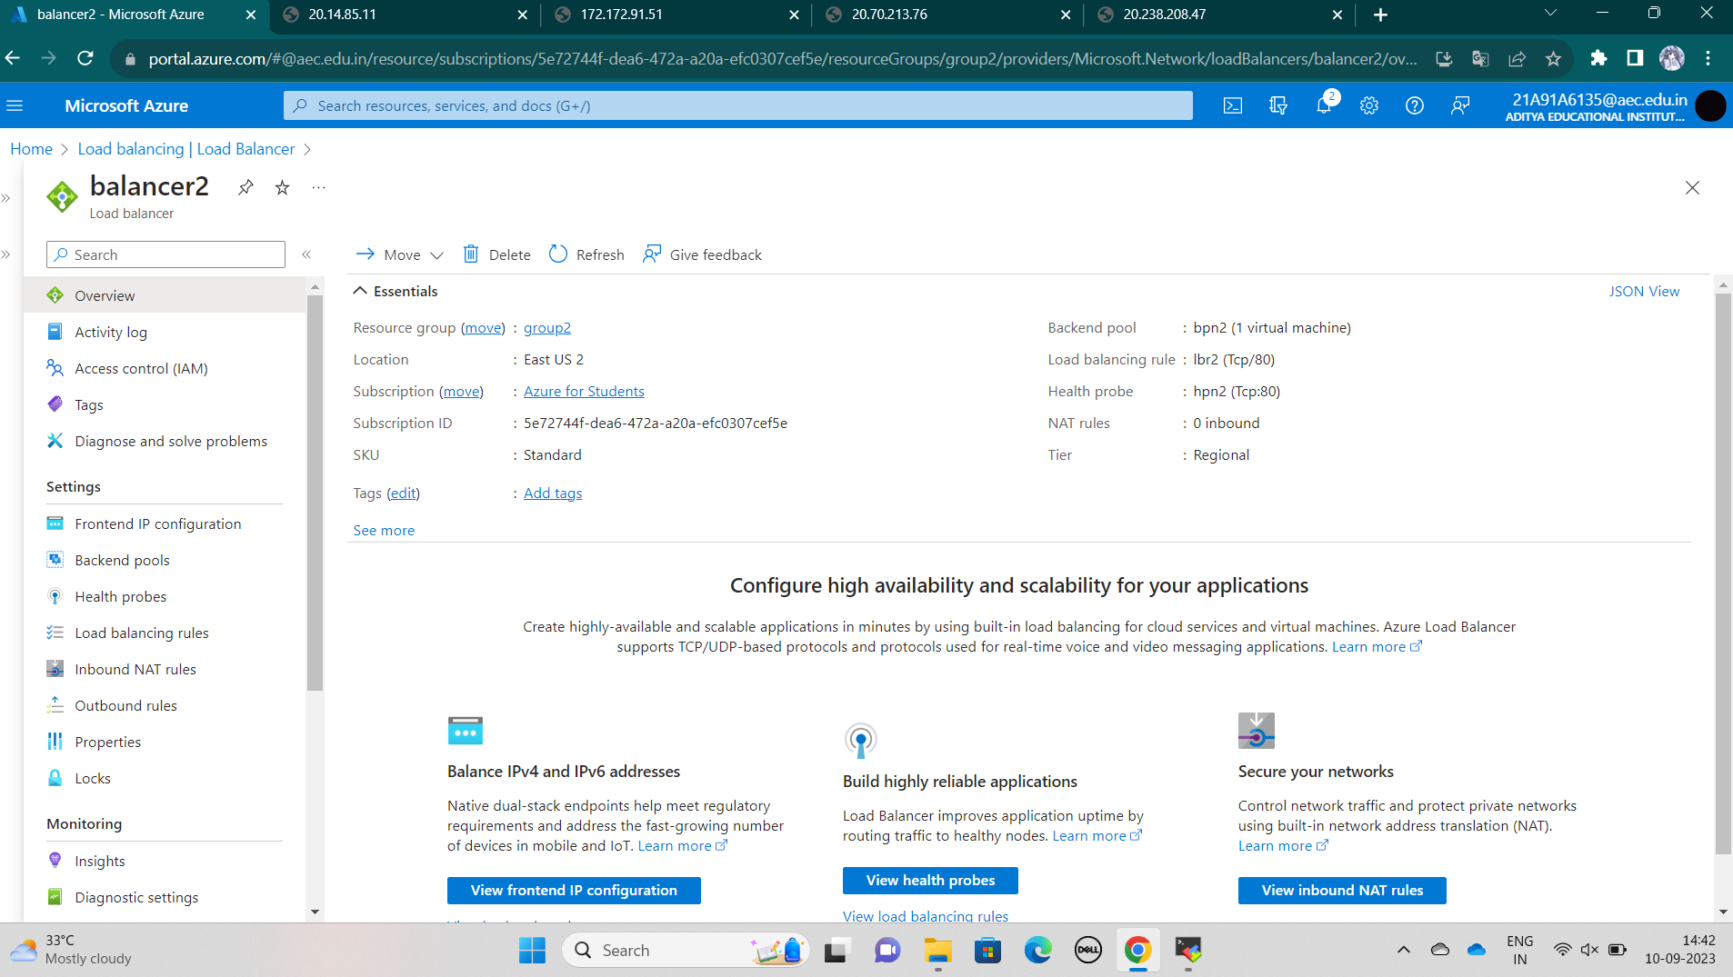

Also the third Virtual Machine is connected to another Load Balancer.

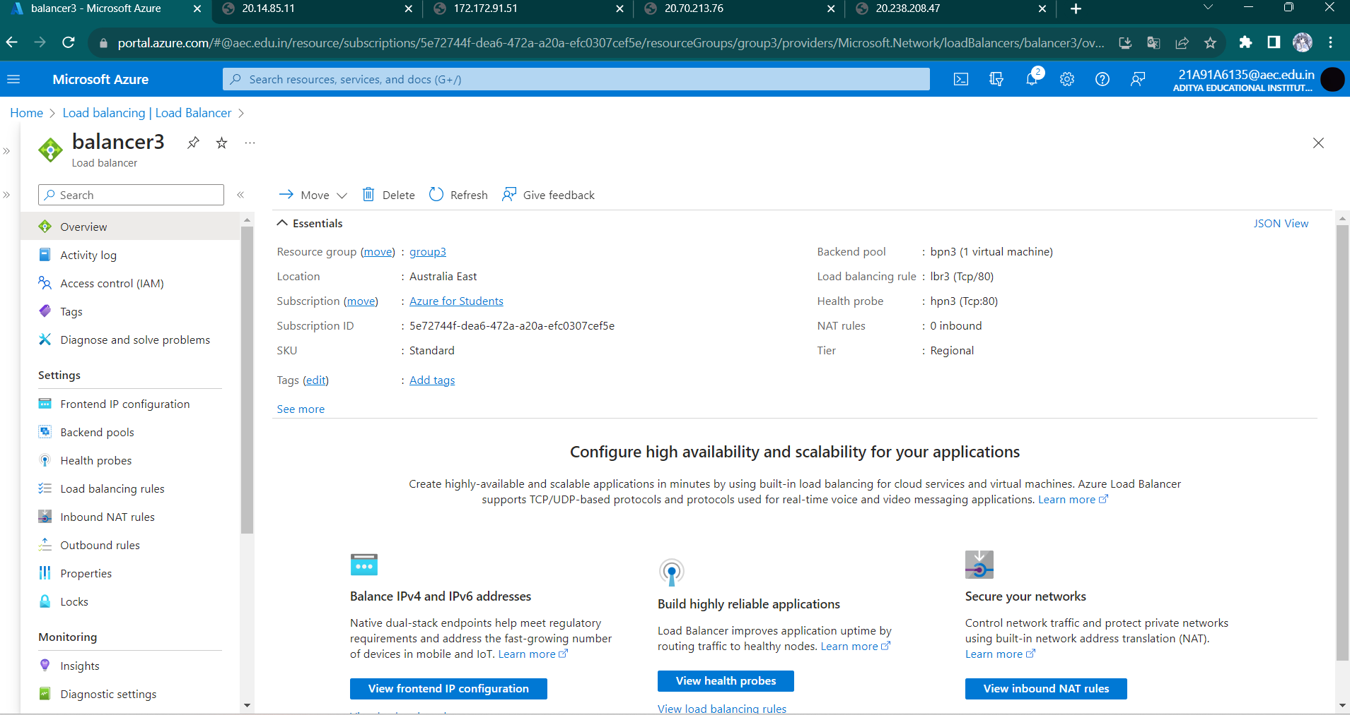

**Step 4:** Now create one global load balancer**.**

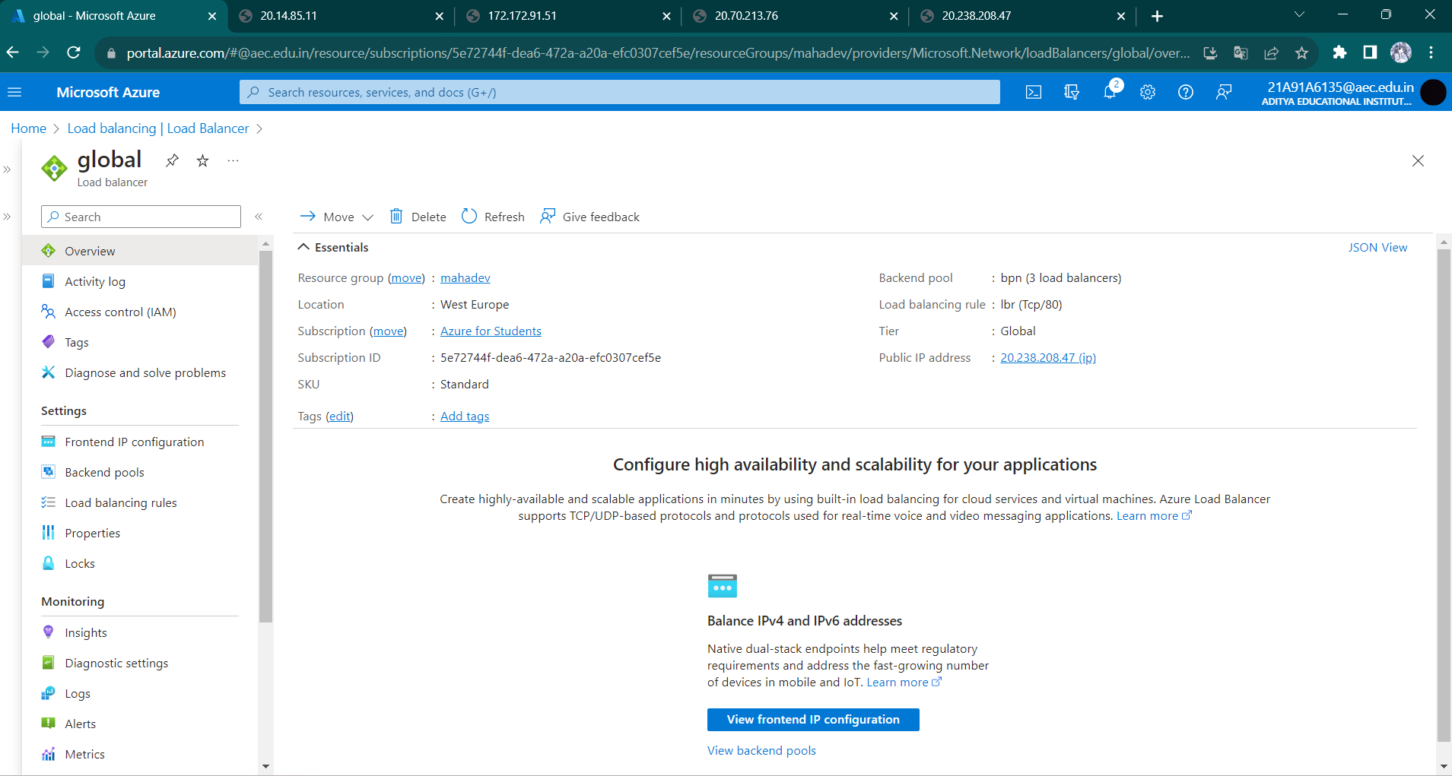

**Step 5**: Now using IP address start the server and insert the date in each server.

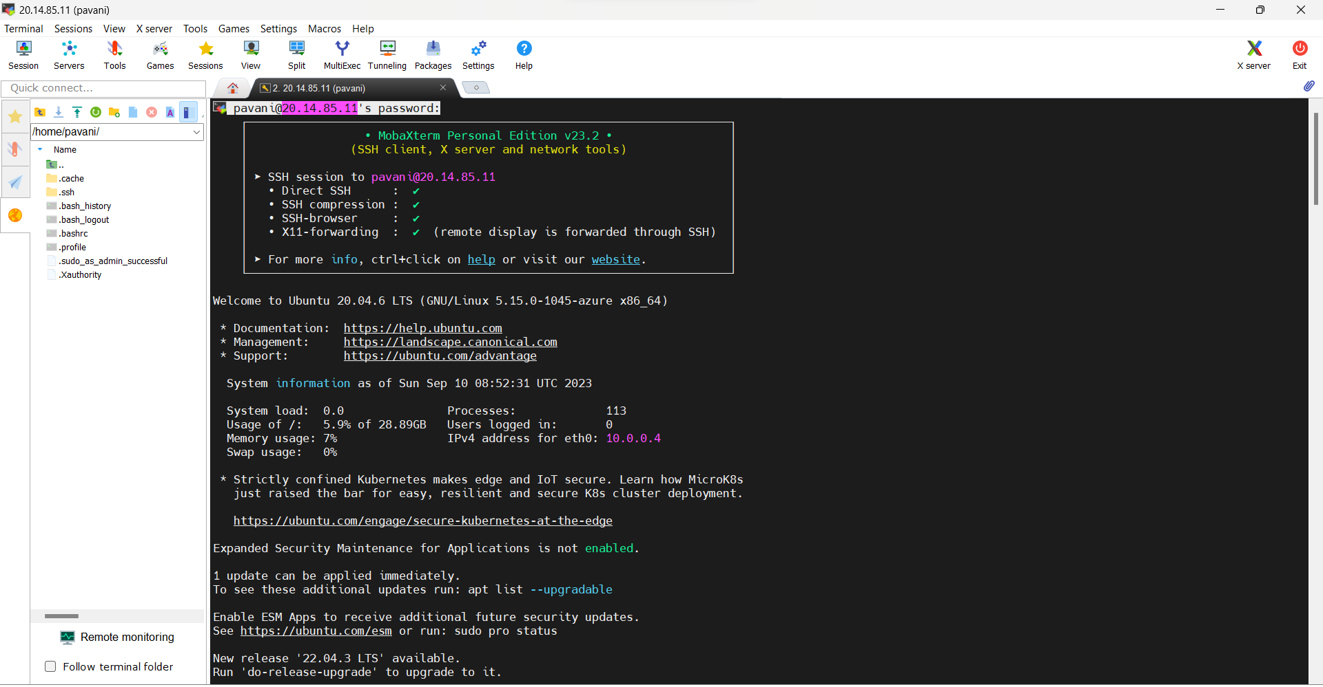

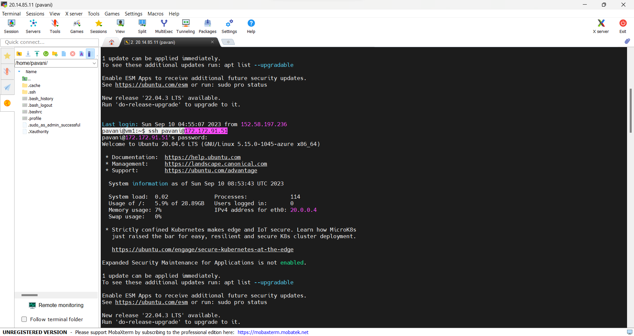

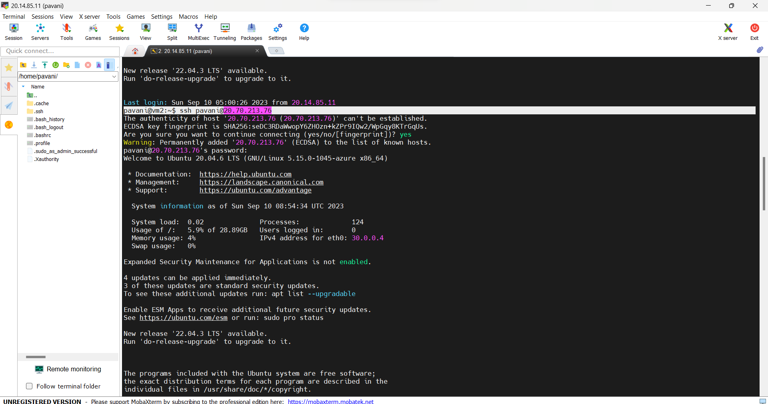

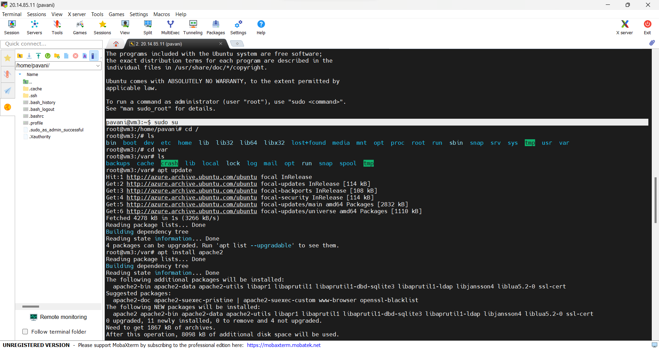

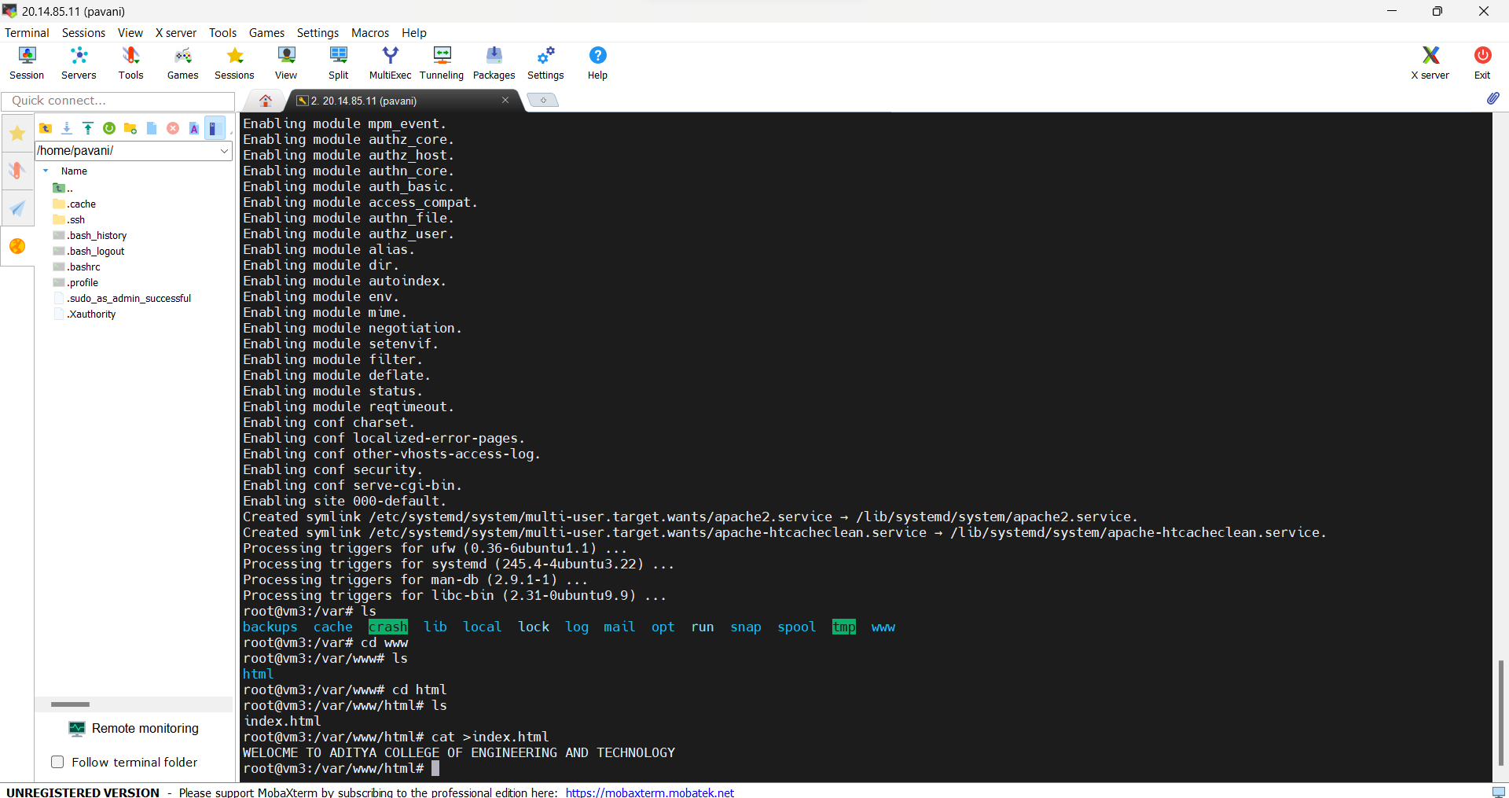

**Step 6:** Now you can see result.

